import matplotlib.pyplot as plt  
from scipy import stats  
  
x = [5,7,8,7,2,17,2,9,4,11,12,9,6]  
y = [99,86,87,88,111,86,103,87,94,78,77,85,86]  
  
slope, intercept, r, p, std_err = stats.linregress(x, y)  
  
def myfunc(x):  
  return slope * x + intercept  
  
mymodel = list(map(myfunc, x))  
  
plt.scatter(x, y)  
plt.plot(x, mymodel)  
plt.show()

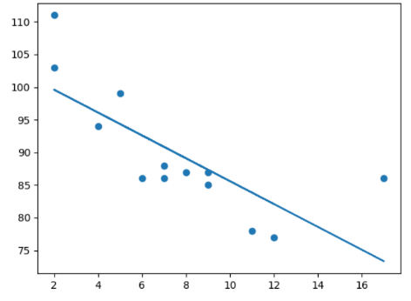

import numpy  
import matplotlib.pyplot as plt  
  
x = [1,2,3,5,6,7,8,9,10,12,13,14,15,16,18,19,21,22]  
y = [100,90,80,60,60,55,60,65,70,70,75,76,78,79,90,99,99,100]  
  
mymodel = numpy.poly1d(numpy.polyfit(x, y, 3))  
  
myline = numpy.linspace(1, 22, 100)  
  
plt.scatter(x, y)  
plt.plot(myline, mymodel(myline))  
plt.show()

